**BUILDING A WEBSITE USING**

**CANVA**

**A PROJECT REPORT**

***Submitted by***

|  |  |
| --- | --- |
| **TEAM MEMBERS** | **NM ID** |
| SHAHRUKH FAKRUDEEN K  (Team Leader) | au311820106021  (6DB5C9C895A29889FDD447D6ED76B0A1) |
| AHMAD SYED SEMAR | au311820106004  (5BC8016528D7C5AB3244B604222FFC54) |
| KISHORE S | au311820106011  (EA766ED7FAFA435A59C457475FE5EE33) |
| AMUDESHWARAN S | au311820106005  (23107AB92A5609EB20243481945462A1) |

***In partial fulfillment of the award of the***

***Degree of***

BACHELOR OF ENGINEERING

**NAAN MUDHALVAN - DIGITAL MARKETING**

**(SmartBridge)**

**MOHAMED SATHAK A J COLLEGE OF**

**ENGINEERING**

**2020 – 2024**

### BONAFIDE CERTIFICATE

Certified that this project report **“BUILDING A WEBSITE USING CANVA”** is the Bonafide work of the following students, **SHAHRUKH FAKRUDEEN K (311820106021), AHMAD SYED SEMAR (311820106004), KISHORE S (311820106011), AMUDESHWARAN S (311820106004)** in partial fulfilment for the award of the **NAAN MUDHALVAN** and the project work is carried out under my supervision.

### ACKNOWLEDGEMENT

This satisfaction and successful completion of any task could be incomplete without mentioning the people who made it possible, whose constant guidance and encouragement crown our efforts with success.

We express our sincere and deep gratitude to our beloved assistant professors and technicians for their kind cooperation, moral support, and encouragement in completing this work. We express our thanks to all those who helped us directly or indirectly in the successful completion of this project work.

### TABLE OF CONTENTS

#### INTRODUCTION

* 1. Project Overview

1.2.Purpose and Customer Problem Statement (Defining Problem Statement)

1.3.Customer Problem Statement

1. **LITERATURE REVIEW**

#### Understanding Digital Marketing

* 1. Importance of Websites in Digital Marketing

#### Role of Canva in Website Development

1. **WEBSITE DEVELOPMENT PROCESS**

#### Conceptualization and Planning for the Website with Brainstorming

* 1. Utilization of Canva for Tailored Branding and Design
  2. Content Creation and Integration Psychological Services
  3. Customization to Reflect Therapure’s Brand Identity with Empathy Map
  4. Testing and Quality Assurance of the Website

1. **EVALUATION AND IMPACT ANALYSIS**

#### Evaluation of Website Design and Layout

* 1. User Experience and Interface Analysis

#### Effectiveness of Canva in Communicating Therapure’s Message

#### RESULTS

* 1. Implications of the Website for Therapure’s Business Model

#### ADVANTAGES AND DISADVANDVANTAGES

1. **FUTURE SCOPE**
2. **CONCLUSION**

**1. INTRODUCTION**

**1.1 Project Overview:**

The core focus of this project lies in the meticulous creation and development of an inclusive and user-centric website for Therapure Psychological Healing. As a dedicated platform catering to individuals seeking holistic healing solutions, the website is tailored to address the multidimensional aspects of psychological, spiritual, and emotional well-being. By integrating intuitive design elements and a seamless user interface, the website aims to provide a comprehensive and immersive experience, guiding users toward a path of self-discovery and healing. This platform is envisioned to serve as a digital sanctuary, offering a range of resources and insights to empower individuals on their transformative journey of inner healing and personal growth. Our emphasis on user-centric design and engaging content is aimed at fostering a sense of comfort and empowerment, ensuring that each visitor feels welcomed and supported throughout their exploration of therapeutic resources and services.

**1.2 Purpose:**

The primary objective behind the development of this website is to establish an accessible and engaging virtual space that effectively communicates the ethos and objectives of Therapure Psychological Healing. Leveraging the creative potential of Canva, the platform is designed to serve as an interactive hub that fosters a deep understanding of diverse holistic healing approaches. Through this medium, the website endeavors to cultivate a sense of belonging and trust among its audience, encouraging active participation and exploration of various psychological, spiritual, and emotional healing techniques. It aims to bridge the gap between seekers and practitioners, facilitating an environment of empathy and support for individuals navigating the intricate landscape of mental and emotional well-being. By providing a seamless and intuitive user experience, the website strives to become a reliable and compassionate companion in the pursuit of inner balance and well-being.

**1.3 Customer Problem Statement:**

At Therapure Psychological Healing, we recognize the challenges faced by individuals seeking comprehensive holistic healing services. Our aim is to understand the unique struggles and complexities experienced by those navigating the realm of psychological, spiritual, and emotional well-being. Through thoughtful engagement and empathetic exploration, we endeavor to address the specific needs and concerns of each individual, fostering an environment of trust, understanding, and support.

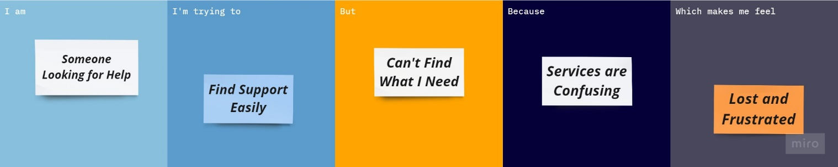Below is an example visual representation of the intricate challenges and concerns faced by individuals seeking holistic healing, providing a comprehensive overview of the customer problem statement.

**2. LITERATURE REVIEW**

**2.1 Understanding Digital Marketing:**

Understanding digital marketing is crucial for businesses to navigate the dynamic online landscape effectively. It involves comprehending the various strategies, such as search engine optimization (SEO), social media marketing, and content marketing, to optimize online visibility and engage with the target audience. By grasping the fundamentals of digital marketing, businesses can create a robust online presence and develop tailored approaches to meet their marketing objectives.

**2.2 Importance of Websites in Digital Marketing:**

Websites serve as the cornerstone of a company's online identity and are essential for establishing credibility and fostering brand awareness. They provide a centralized platform for businesses to showcase their products and services, share valuable content, and facilitate seamless interaction with their audience. With the rise of e-commerce and digital interactions, having an engaging and informative website has become a prerequisite for businesses to remain competitive in the digital marketplace.

**2.3 Role of Canva in Website Development:**

Canva revolutionizes website development by providing a user-friendly interface and an extensive library of design templates, graphics, and fonts. It empowers even non-designers to create visually appealing web content, including engaging banners, info graphics, and social media posts, without the need for extensive design expertise. Its intuitive drag-and-drop functionality and diverse customization options make it an indispensable tool for businesses looking to enhance their online presence and effectively communicate their brand story through compelling visual narratives.

**3. WEBSITE DEVELOPMENT PROCESS**

**3.1 Conceptualization and Planning for the Website with Brainstorming:**

During the initial phase of website development, the team at Therapure Psychological Healing engaged in a comprehensive process of conceptualization and planning. Through collaborative brainstorming sessions and idea generation, we meticulously outlined the key components and features essential to creating an immersive and user-friendly virtual space. By focusing on user experience and incorporating valuable insights from diverse perspectives, we formulated a strategic roadmap that laid the foundation for a cohesive and intuitive website structure.

Driven by a commitment to innovation and user-centric design, the following diagram illustrates the collaborative brainstorming process undertaken by the team at Therapure Psychological Healing. Through dynamic idea generation and thoughtful deliberation, we laid the groundwork for a comprehensive and engaging website that caters to the diverse needs of our valued users.

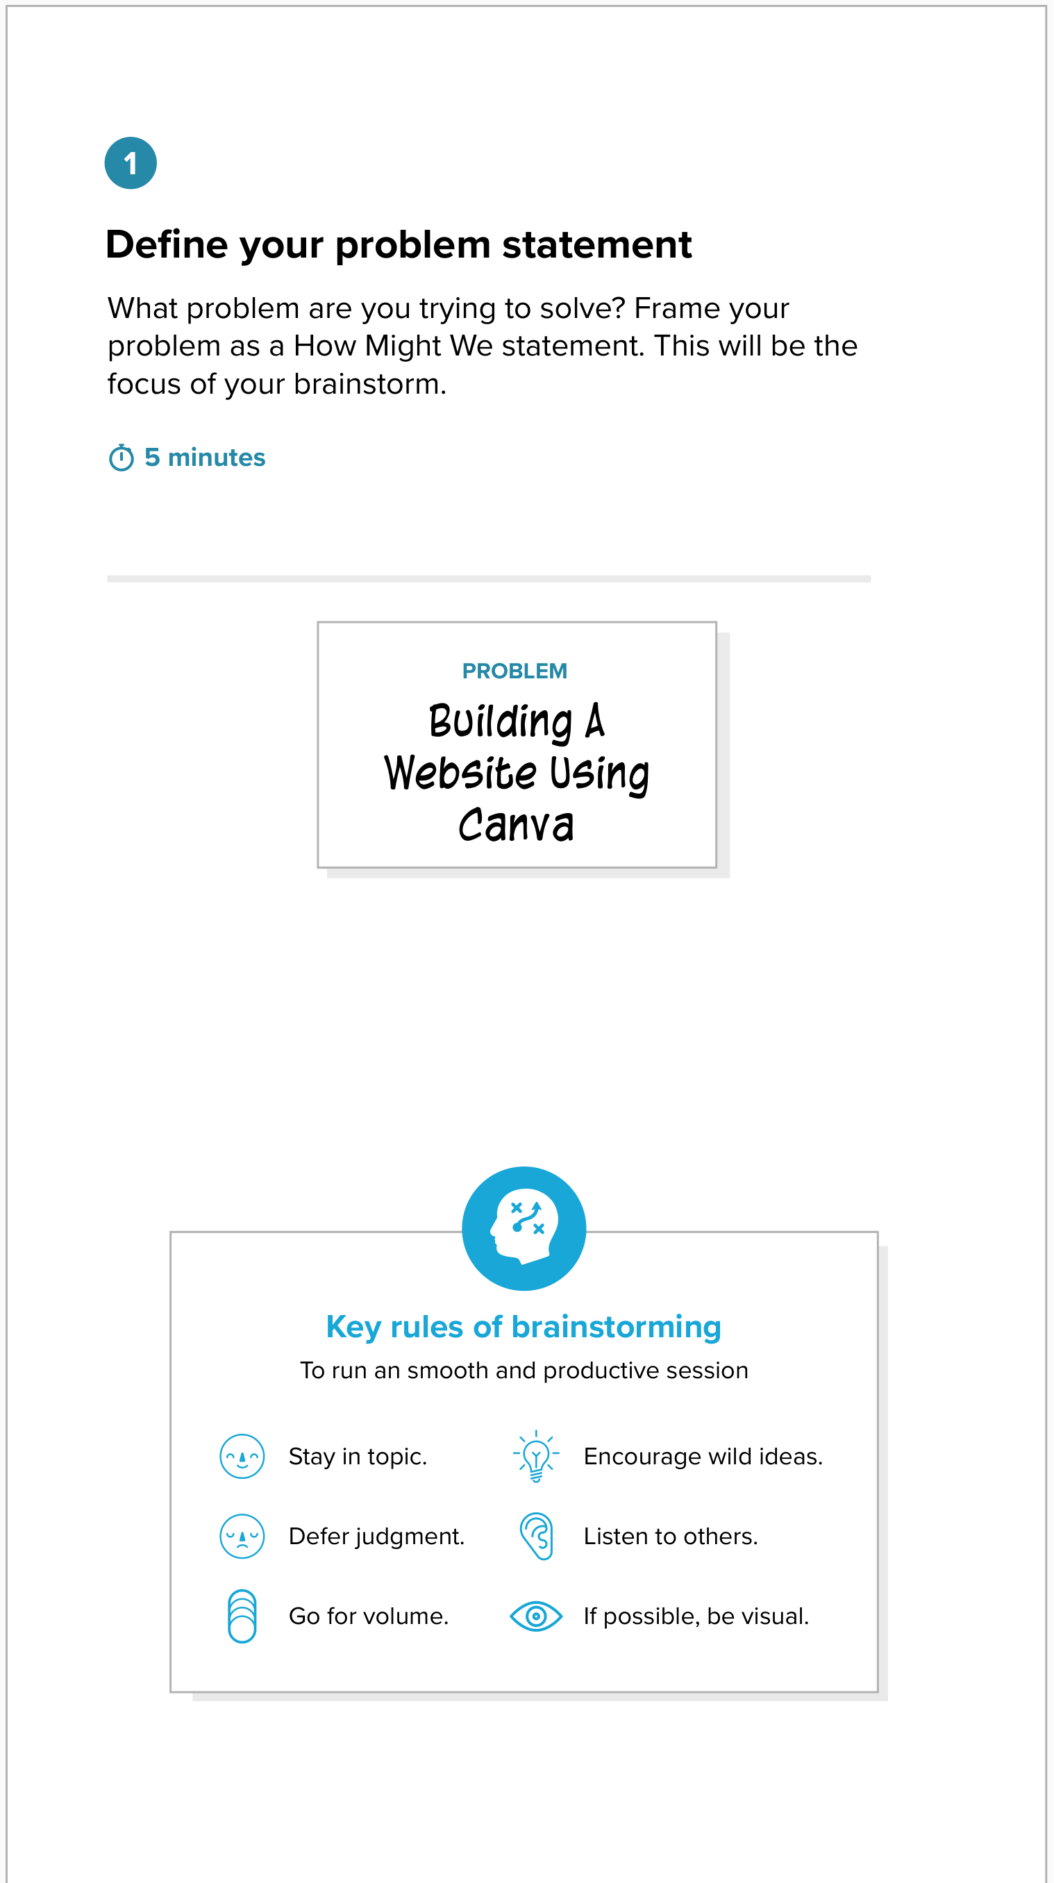

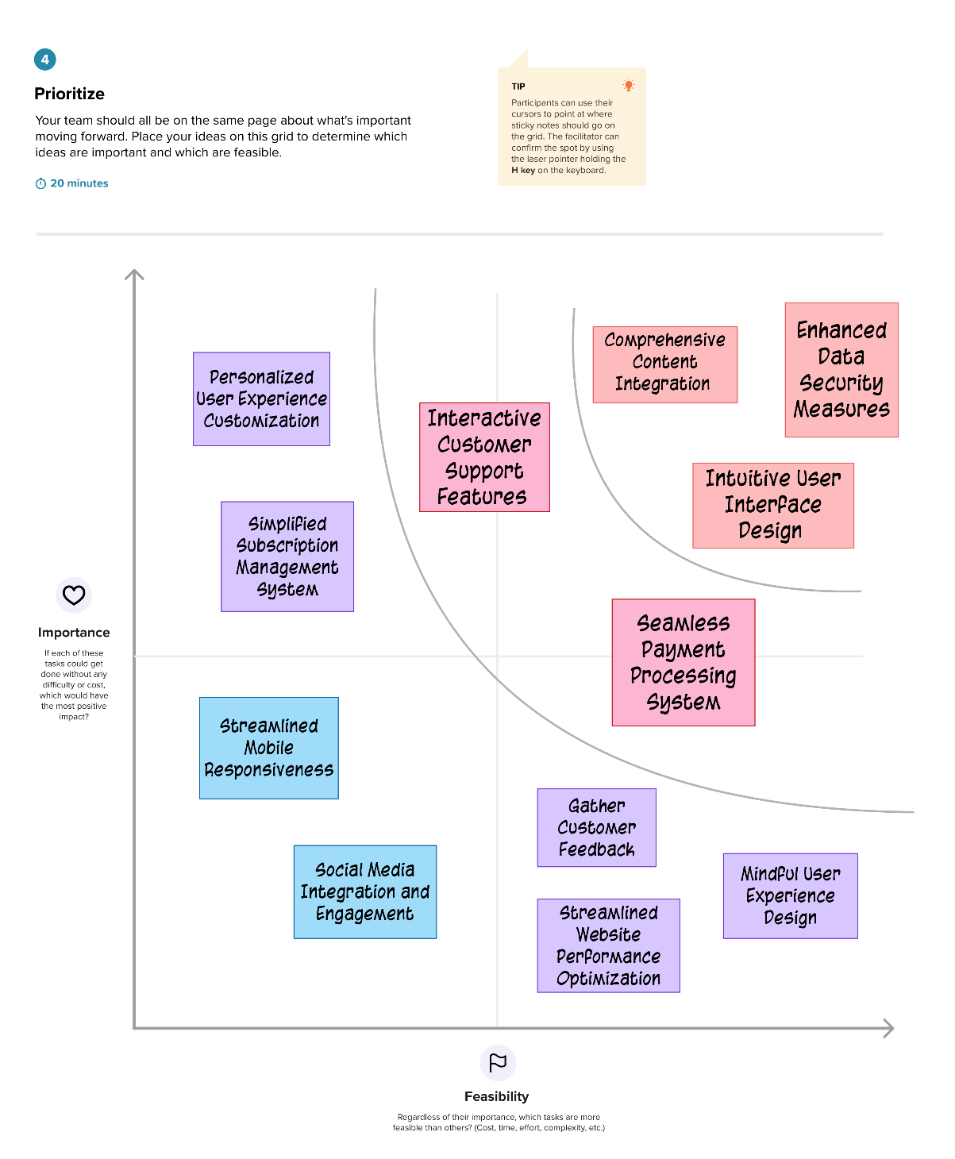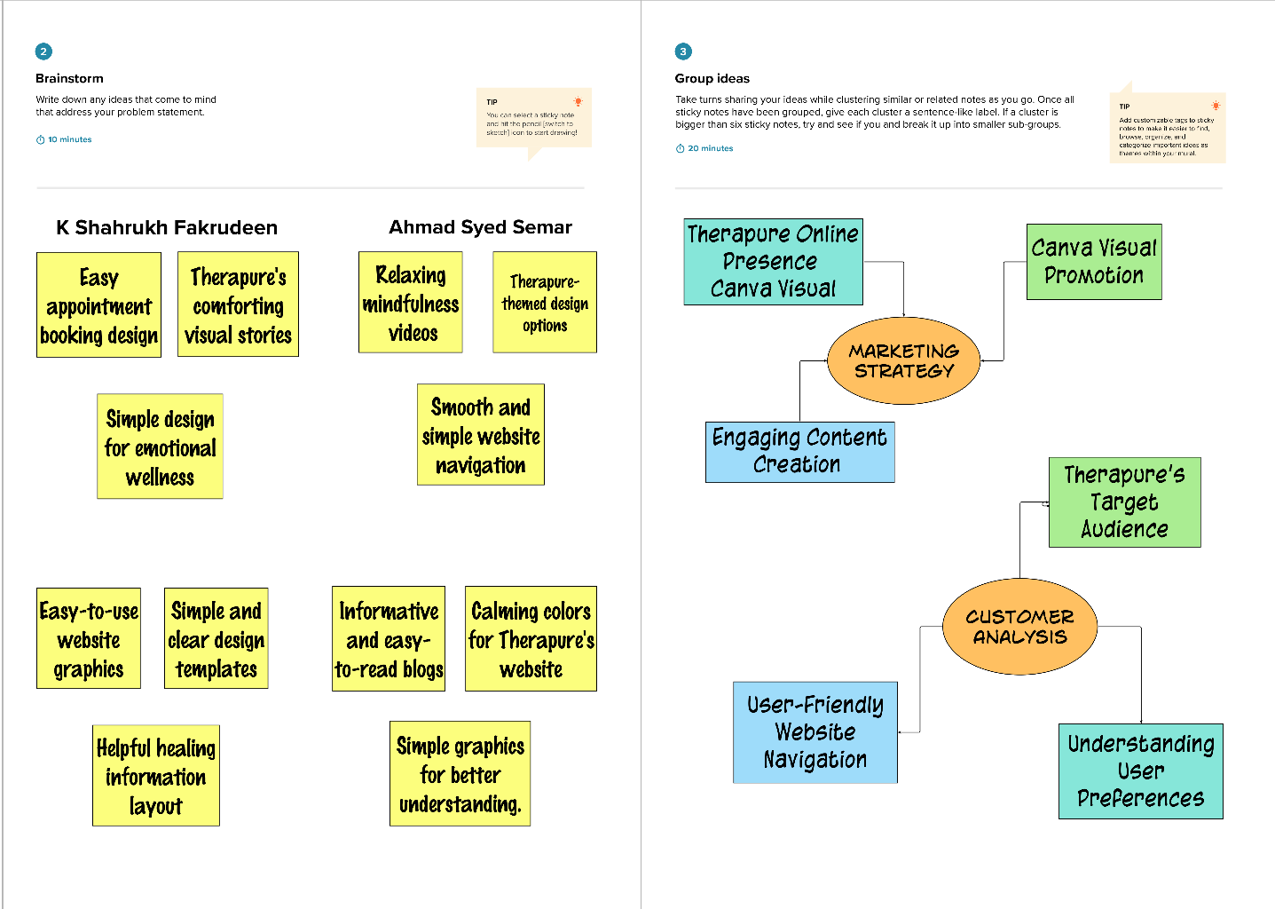

**3.2. Utilization of Canva for Tailored Branding and Design:**

In the phase focusing on the utilization of Canva, our team harnessed the platform's diverse design tools to craft a visually compelling and cohesive brand identity for Therapure. Leveraging Canva's intuitive features, we curated a range of tailored branding elements, including captivating logos, engaging graphics, and visually appealing color schemes, all meticulously aligned with Therapure's core values and mission. This strategic utilization of Canva enabled us to establish a distinct and memorable visual presence that resonates with our target audience and effectively communicates the essence of Therapure's holistic healing approach.

**3.3. Content Creation and Integration for Psychological Services:**

In the process of content creation and integration, our team meticulously curated and developed a range of informative and empathetic resources tailored to the diverse psychological needs of our users. Through the strategic integration of relevant and engaging content, including insightful articles, informative videos, and interactive tools, we aimed to provide a comprehensive and supportive online environment for individuals seeking holistic psychological services. By ensuring seamless content integration, we endeavored to foster a sense of trust and understanding, providing visitors with valuable insights and resources to facilitate their journey toward emotional well-being and personal growth.

**3.4 Customizing to Reflect Therapure’s Brand Identity with Empathy Map:**

Through meticulous customization, we tailored the website to encapsulate Therapure's essence, fostering immediate connection and understanding. Integrating emotionally resonant elements, our goal was to craft an immersive online journey exuding feelings of comfort and trust. Aligning every aspect of the website with Therapure's mission, we aimed to establish an online environment reflecting the holistic healing approach at the heart of Therapure.

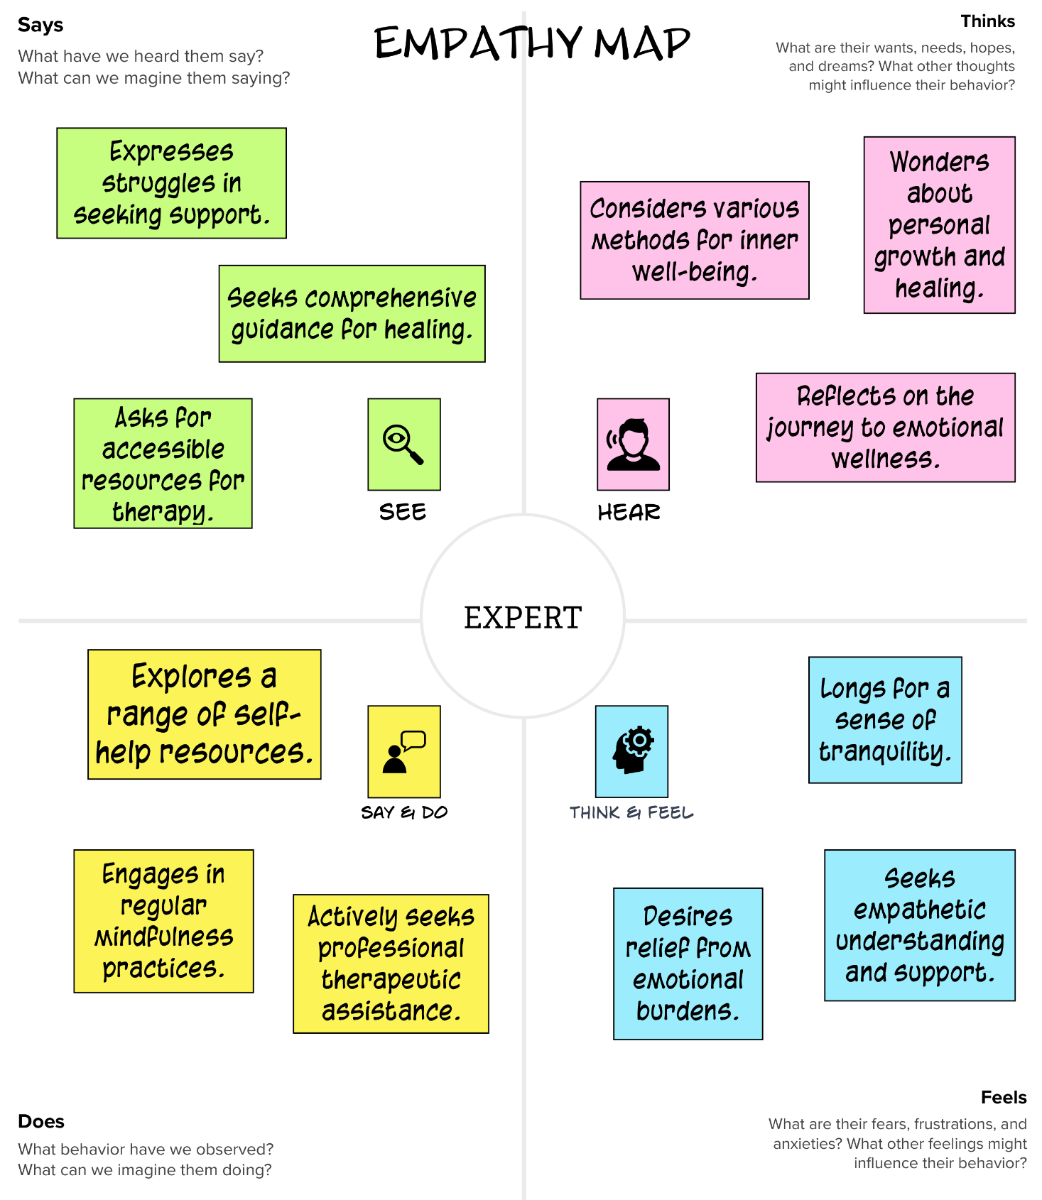Understanding the nuanced emotional landscape of our audience is crucial to delivering a truly empathetic online experience. Below is an illustration representing the deep insights garnered from the empathy map, serving as a guiding compass in tailoring the website to meet the diverse emotional needs of our valued users.

**3.5 Testing and Quality Assurance of the Website:**

In this phase, we conducted rigorous testing and quality assurance measures to ensure that every aspect of the website aligns seamlessly with the user's expectations and the objectives of Therapure. Our team thoroughly examined the website's functionality, user interface, and overall performance, addressing any technical issues or glitches to guarantee a smooth and intuitive user experience. Through comprehensive quality checks and user testing, we aimed to deliver a reliable and user-friendly online platform that upholds the standards of excellence synonymous with Therapure's holistic healing mission.

**4. EVALUATION AND IMPACT ANALYSIS**

**4.1 Evaluation of Website Design and Layout:**

Through a comprehensive evaluation process, we meticulously assessed the website's design and layout to ensure that it effectively conveys Therapure's ethos and resonates with the audience's emotional journey. Our aim was to create an inviting and user-friendly interface that fosters a sense of trust and engagement, encouraging visitors to explore the diverse resources and services available on the platform.

**4.2 User Experience and Interface Analysis:**

Conducting a thorough analysis of the user experience and interface, we focused on enhancing the website's accessibility and usability, aiming to provide visitors with an immersive and seamless online journey. By addressing user feedback and implementing intuitive design elements, we aimed to optimize the overall user experience, enabling individuals to navigate the website effortlessly and find valuable resources that support their psychological well-being.

**4.3 Effectiveness of Canva in Communicating Therapure’s Message:**

By evaluating the effectiveness of Canva in conveying Therapure's core message, we gauged the platform's ability to visually communicate the brand's holistic healing mission and values. Leveraging Canva's versatile design tools, we aimed to create a visual narrative that resonates with our audience, fostering a deep understanding of Therapure's empathetic approach to psychological, spiritual, and emotional well-being. Our analysis focused on the harmonious integration of Canva's graphics, typography, and layout to effectively convey the brand's compassionate and supportive presence in the digital space.

**5. RESULTS**

**5.1 Implications of the Website for Therapure’s Business Model:**

The website's seamless integration of therapeutic resources has not only facilitated a stronger connection between users and the brand but has also contributed to the establishment of a more robust and credible online presence, enhancing Therapure's overall brand recognition and market positioning in the holistic healing industry. This enhanced visibility and user engagement have fostered a loyal and expanding user base, generating new opportunities for strategic partnerships and service expansions within the holistic healing sector.

The website's successful alignment with Therapure's core values and mission has reinforced the brand's commitment to providing accessible and comprehensive holistic healing resources, solidifying its position as a leading and trusted platform for individuals seeking professional guidance and support in their journey towards emotional and psychological well-being.

**6. ADVANTAGES**

**6.1 Advantages:**

1. **Enhanced accessibility to psychological resources and support:** The website provides easy access to a wide range of therapeutic materials and services for individuals seeking emotional and psychological well-being.
2. **Improved user engagement and connection with the brand:** Through its user-friendly interface and engaging content, the website fosters a stronger connection and interaction between users and the Therapure brand.
3. **Strengthened brand recognition and market positioning:** The website's seamless integration of Therapure's ethos and values enhances the brand's recognition and establishes its position as a reputable entity in the holistic healing industry.
4. **Expanded opportunities for strategic partnerships and collaborations:** The increased online presence and user engagement open up new possibilities for forming strategic partnerships and collaborations within the holistic healing sector.
5. **Increased visibility and reach within the holistic healing industry:** The website's effective implementation expands Therapure's visibility, enabling it to reach a wider audience and gain prominence in the holistic healing community.

**7. Future Scope:**

The future scope of our project holds exciting possibilities for further development and enhancement, as we continue to innovate and improve our solution. Here are some refined and enhanced ideas for future expansion:

1. **Integration of Advanced Technology:** The incorporation of emerging technologies such as artificial intelligence and virtual reality holds the potential to enhance the user experience and provide more personalized and interactive therapeutic solutions.
2. **Expansion of Service Offerings:** Diversifying the range of holistic healing services and introducing specialized programs tailored to specific user needs can broaden the platform's appeal and cater to a more extensive audience seeking comprehensive psychological support.
3. **Global Outreach and Multilingual Support:** Enabling multilingual functionality and expanding the platform's accessibility to a global audience can foster inclusivity and cater to individuals worldwide who seek psychological healing resources in their native languages.
4. **Community Building and User Engagement:** Establishing a robust online community through interactive forums, support groups, and live sessions with professionals can create a sense of belonging and foster meaningful connections among users navigating their emotional well-being journey.
5. **Continuous Innovation and User-Centric Upgrades:** Implementing a culture of continuous innovation and incorporating user feedback into regular updates can ensure that the platform remains dynamic and responsive to evolving user needs, maintaining its relevance and appeal within the holistic healing landscape.

**8. CONCLUSION**

In conclusion, the Therapure Psychological Healing website represents a significant stride in the digital sphere of holistic wellness. By harnessing Canva's creative potential and prioritizing user-centric design, we've crafted a virtual platform that not only provides comprehensive psychological resources but also fosters empathy and understanding for those on a spiritual and emotional quest. Our meticulous planning, customization efforts, and rigorous quality assurance have resulted in an immersive online space that embodies Therapure's compassionate values.

Looking forward, our commitment to continuous innovation and growth drives us to broaden our reach, elevate user engagement, and remain steadfast in providing accessible holistic healing resources to a global audience. Building this website has underscored the vital role of technology in nurturing connections and support for individuals navigating their personal healing journeys. Our focus on user-centric design and meaningful content integration serves as the cornerstone of a thriving online community centered on holistic well-being, emphasizing the significance of emotional support and guidance in today's fast-paced digital landscape.

As we reflect on the completion of this project, we recognize the transformative impact of technology in cultivating inclusive and compassionate spaces for individuals to seek solace and guidance. The Therapure website stands as a testament to our dedication to addressing the emotional, psychological, and spiritual needs of our users, providing a nurturing virtual environment where individuals can embark on their paths of self-discovery and healing. Our ongoing commitment remains focused on enhancing our platform, ensuring it continues to serve as a beacon of hope and support for all individuals seeking solace and guidance in their pursuit of holistic well-being.